**Save our Stories: The Big WW2 Preservation Weekend**

Thank you for helping out with the University of Oxford’s big push to save and preserve stories and objects from Britain and the Commonwealth during the Second World War. We are looking for any stories about your family or friends, or local area. It can be written down, photographed, recorded, or all three!

Just follow the 3-steps:

Find the story – find a story or stories about members of your family, your friends, or the local area during the war. This can be about people who served, people on the home front, children, stories passed down, objects you still keep. Every Story Matters.

Capture the Story – write it down, type it, take photographs, film an interview.

Send us the Story

There are several ways you can do this:

1. Use our web upload form at: <https://tinyurl.com/sos-submit> or  
     
   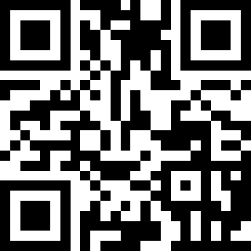  
     
   – you’ll be asked to either upload a scan of a completed ‘Story/Consent’ form or type in details about the story, and then add any files (e.g. photos, recordings, etc).
2. Post it to us at: c/o Dr S Lee, ITS, 13 Banbury Road, Oxford OX2 6NN. **N.B. If you do this please also send us a completed ‘Story/Consent’ form signed by a you as a parent/guardian/responsible adult or complete the online form you will be pointed to in our ‘thank you’ reply message. If you don’t have the form you can get a copy from https://theirfinesthour.english.ox.ac.uk/sos-schools**
3. Email everything to us at sos@it.ox.ac.uk . **N.B. If you do this please also send us a photograph of a completed ‘story/consent’ form signed by you as a parent/guardian/responsible adult or complete the online form you will be pointed to in our ‘thank you’ reply message. If you don’t have the form you can get a copy from https://theirfinesthour.english.ox.ac.uk/sos-schools**
4. Or ask the teacher to help your child upload the material. **N.B. If you do this please also give your pupil a photograph or a paper version of a completed ‘story/consent’ form signed by you as a parent/guardian/responsible adult.**