YOUR SECOND WORLD WAR STORY
Please try to complete both sides of this form.
What is the Second World War STORY you have found?
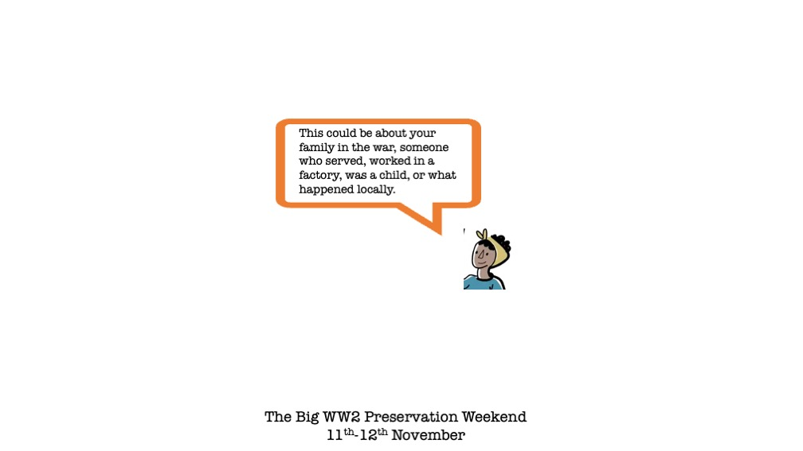

IS THE STORY ABOUT SOMEONE, IF SO WHO?  HOW ARE THEY RELATED TO YOU? | 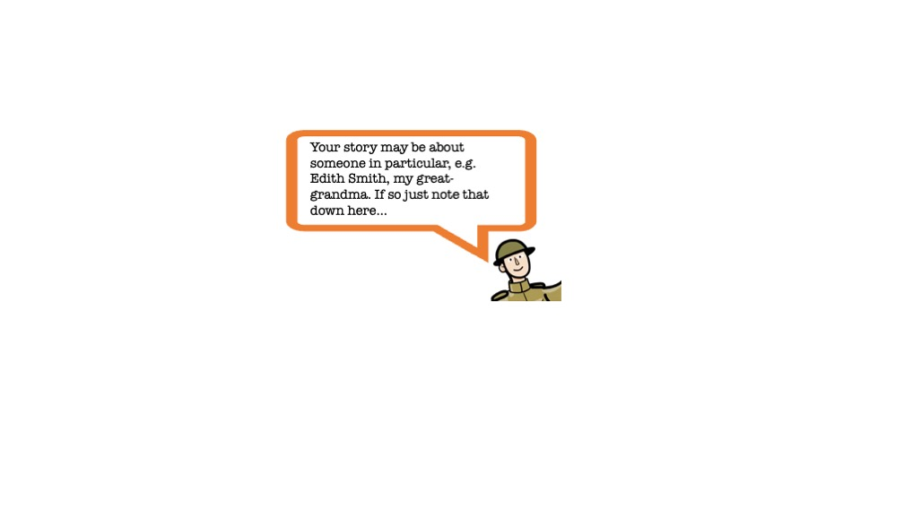
ARE YOU SENDING US ANYTHING ELSE? | 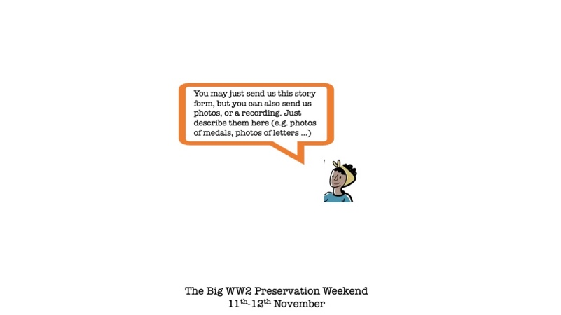

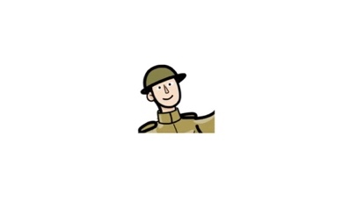 You now need to get a parent or guardian to complete the second side of this form!

CONSENT
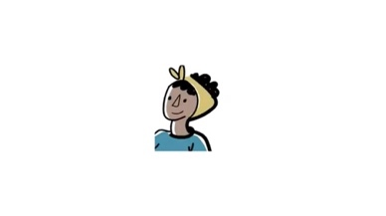This needs to be completed by a parent or guardian. You should take a photo of both sides of this form and send it to us!
NAME OF PARENT/GUARDIAN:
CONTACT EMAIL OR TELEPHONE:
NAME OF SCHOOL:
These next questions are to make sure you have understood what the project is about (digitally saving stories from the Second World War) and agree to taking part and saying that anything you send can be made freely available online by the University of Oxford for anyone to use, share, and adapt for any purpose as long as they say it was from this project.
Please tick each box if you agree with the statement
I confirm that I have received or had the opportunity to read the Parent Information Pack about the project. |  | I confirm that the story/material we sent you belongs to me/us, or the owner of these materials has allowed me to submit  the materials on their behalf.
I agree to take part and understand that I can ask for my what we send you to be taken down without giving any reason by emailing the project. |  | I confirm that we own the copyright in the story/material sent you, or the owner of these rights has given permission for the story/materials to be sent.
I agree that my name and email/phone will be retained in a secure database so that the project can contact me if needed. I understand who will have access to this. |  | I confirm that I know of no reason why the story/material sent to you cannot be used in this project as described.
I give permission for you to contact me again to clarify information and provide me with further information about the project. |  | 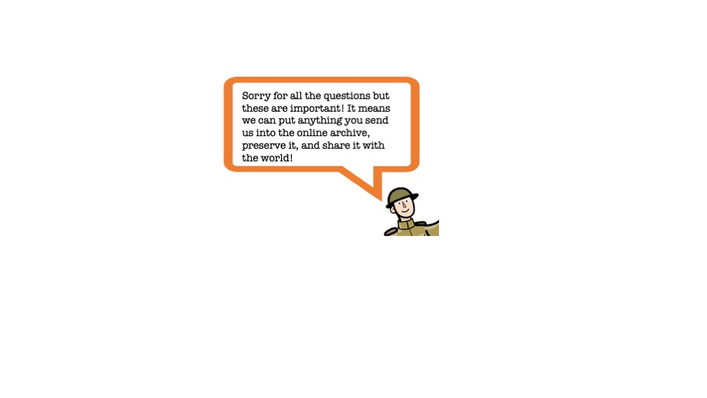
FINALLY BY CHECKING THE BOXES BELOW, YOU ARE AGREEING THAT THE UNIVERSITY OF OXFORD CAN PUT THE MATERIAL YOU SENT US ONLINE FOR ANYONE IN THE WORLD TO USE, SHARE, ADAPT AND/OR REUSE FOR EDUCATIONAL, NON-COMMERCIAL AND COMMERCIAL PURPOSES:
 | Your Story
 | Any Photographs of Objects and Documents and the Information about those Object(s)
 | Any audio or video recording
 | Your name (IF NOT SELECTED YOU WILL BE LISTED AS ‘ANONYMOUS’)

–––––––––––––––––––––––––––––––––––– –––––––––––– –––––––––––––––––––– 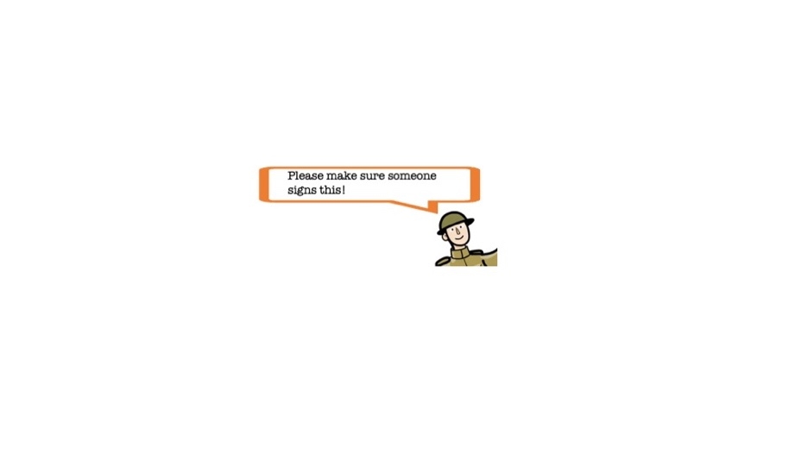
NAME OF PARENT/GUARDIAN (Capitals) DATE SIGNATURE
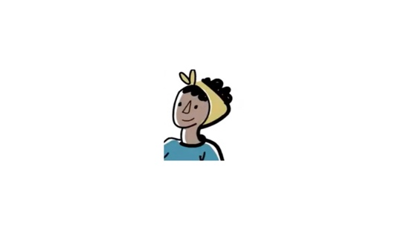 Thank you so much for helping out! Now you need to photograph or scan these two pages and send them to us along with everything else! Full instructions on how to do this are available at tinyurl.com/xxx or at the code below

